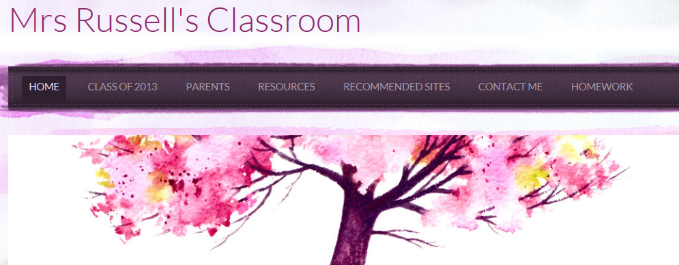

Dear Parents and Caregivers,

My name is Belinda Russell. I am the classroom teacher of the Year 4/5 class at Landsdale Primary School in 2013. The year 5’s at Landsdale are part of the 1 to 1 laptop program offered by the school and the Year 4’s in my class are going to be included in that program.

I understand that buying a laptop for your 9/10 year old child is big decision and I wanted to take some time out to give you an overview of my philosophy regarding digital technologies in the classroom and how I envision using the technology in the classroom next year.

I am extremely excited about the possibilities open to a classroom that has access to digital technology throughout the school day. I believe that digital technologies, when used effectively, can enhance student learning. Students are engaged by reading programs that integrate sound, video, graphics and text. Having access to immediate information, they are encouraged to research, learn and focus on any given subject, creating students who are self-directed learners. Students will learn cyber safety and digital skills in an authentic context that is relevant to them.

I understand that some parents may feel apprehensive about the program and I would like to address some of the concerns.

Expense

The laptops are costly; however, students will be able to use the laptop from Year 4 through to high school. Being able to purchase the laptop in Year 4 ensures better value for money because students are using them for 4 years of Primary School as opposed to the Year 5’s who will use them for 3 years of Primary. Students will use their laptops daily. There will not be a ‘technology hour’ in my classroom. The technology will be embedded in my classroom programming. I am putting the finishing touches on my classroom website for 2013 (the header at the top of this page is a screenshot from the website) and all subjects will be accessed, where appropriate, using the website. Students will have links to class content, video clips and podcasts of lessons, revision activities and links to educational websites that enhance the classroom teaching and learning program. Students will be able to access this content from any computer, wherever they are, from our class website.

Appropriate Use

Students have access to technology throughout their lives. Part of the laptop program is ongoing lessons and discussions regarding the safe and appropriate use of online services. As part of our Health program students will spend the first term exploring cyber safety and cyber etiquette. These students will have an advantage over students who have access to computers only at home or in their hour at the computers at school because they will have a context to embed their learning. The class will not only have their website, we will have a class social networking site called Edmodo (www.edmodo.com.au) This is a site where students from our class can talk, post links to educational websites, completes polls and quizzes that I set. I have used this site in 2012 and found it was a fantastic way to introduce cyber etiquette in social media. The Edmodo class link is only for our class members and outsiders are not able to join. Parents have their own code with a link to the site so they can see what their child (only their child) is posting.

Handwriting Skills

Although our classroom activities will be predominantly technology based, there will be many times that students are required to write for a purpose. Students may write scripts, draft reports, narratives and may use the technology to record their piece of writing, to listen back to when editing, create a podcast, a Prezi/ PowerPoint, they may turn their script onto a movie. Handwriting will still be taught in its traditional format.

Games

Students will not be allowed to play games that are not considered educational during class time. The students will however learn about game design how to create their own games. Any games used in the class will have an educational basis.

Schools are moving towards full implementation of the Australian Curriculum and imbedded throughout the curriculum are outcomes connected directly to the use of technology. Our class will be able to fully engage with the curriculum outcomes, as we will have the technology to do it. I hope that I have addressed any concerns that you may have and I am happy to discuss any further concerns with you.

Kind Regards,

Belinda Russell

Attached to this letter are some examples of the Year 4-5 Student Expectations for ICT. This information has been adapted from (http://education.qld.gov.au/smartclassrooms/documents/enabling-learners/pdf/student-expectations-4-5.pdf)

By Year 5, students explore and use ICT in the processes of inquiry across key learning areas.

Use ICT in the processes of inquiry and research;

- select and use ICT appropriate to the inquiry including online and database formats
- conduct simple Internet searches for information and digital content
- apply useful keywords and phrases when searching for information online
- use digital concept mapping to organise ideas and information into main ideas and supporting details
- identify the inquiry focus of an investigation and match the appropriate digital information sources
- evaluate data and information gathered for usefulness, credibility, relevance and accuracy
- reference valid sources of information

Reflect on the value of selected ICT in the inquiry process;

- reflect on how ICT sources and tools have assisted their inquiry
- compare different ICT sources for credibility

By the end of Year 5, students experiment with, select and use ICT to create a range of responses to suit the purpose and audience. They use ICT to develop understanding and demonstrate creativity, thinking, learning, collaboration and communication across key learning areas.

Select and use ICT to create a range of products to suit the purpose and audience;

- plan, create and refine digital products for specific purposes in a range of KLA-related contexts
- combine their own text and/or images with imported materials to create products
- design and create a multimedia presentation combining text, animation, graphics and sound
- create simple digital concept maps when planning to create products
- use ICT tools to repeat design elements to create patterns
- demonstrate ownership of digital work by naming, sharing and
- discussing products and gathering feedback

Reflect on their use of ICT
- articulate the benefits of creating a digital product as creative tools

By the end of Year 5, students experiment with, select and use ICT across key learning areas to collaborate and enhance communication
Explore different digital media to communicate and collaborate; they:

- compose email to suit the purpose and audience and use electronic address list to communicate with groups
- use a range of online communication tools to share ideas and information
- participate in collaborative online projects with peers and online experts
- use digital concept mapping tools to present ideas and show relationships between main ideas and supporting details
- use spread sheet software to present data and communicate findings
- use word processing, publishing and presentation software to convey messages and meanings for specific audiences through text and images
Apply standards and conventions when using ICT to communicate; they:

- use correct conventions of the email genre when composing and sending messages
- know that digital texts can be edited to improve the effectiveness of communication
- determine and select appropriate communication devices for
- particular audience and purpose
- use editing features of software such as spelling and grammar tools to
- improve writing for publication
- use consistent text and image formatting and page designs in digital
- products
Reflect on their use of ICT and identify ways to improve their effectiveness of communication;

- reflect on the editing process to improve effectiveness of
- communication
- consider the use of email when communicating with groups
- reflect on the choice of software used to communicate ideas
Use ethical, safe and responsible practices when working with ICT;
- apply codes of practice that promote safety, responsibility and respect when working in online and standalone ICT environments
- identify and acknowledge the owner/creator of digital sources and cite online references consistently following agreed conventions
- use and maintain personal passwords for access to files and the school network
- respect the privacy of others understand safety strategies including those relating to stranger danger in online environments
- use positive social skills consistently in ICT communications
- consolidate their understanding of netiquette, such as showing respect for others when communicating in online environments
- comply with school expectations and protocols when using ICT

Reflect on how ICT are used in the community and identify ways they can impact people
- reflect on experiences and evaluate practices in terms of being socially aware, safe, responsible and respectful
Operate ICT efficiently and safely;
- have keyboard proficiency
- independently log on and off the school network
- differentiate between hardware and software
- distinguish between input, output and storage devices
- use a range of input, output and storage devices, understand how these devices work together and select the devices most suited to specific tasks
- use a digital camera to capture images
- use school printers to complete specific printing tasks, such as select network printer within the print dialogue box; select printing properties; load paper; change ink cartridge; check printer connection cable; connect printer to computer; and check printer properties
Navigate software and virtual environments;

- use and understand common choices within the file menu of different applications
- navigate virtual and software environments, including learning objects, games, websites and publishing software
- use editing features to improve drafts of writing, presentations, email and published products
- navigate spreadsheet software to explore, record and collate data, perform simple statistical calculations, construct simple tables and graphs, change values and observe results, format data and transfer to writing or publishing software
- use concept mapping software to represent related ideas and information diagrammatically
- use digital photograph and movie making software
- access Help features within programs when required

