Task 1

Return of the Flowers

1. In the Dreamtime story ‘Return of the Flowers’ who created Earth?
2. What happened when Biame went to the sacred mountain to rest?
3. How did the people feel when this happened?
4. Who went to the Sky Camp?
5. What did the Wirinuns do with the flowers?
6. How do you feel about bushland being cleared for houses and buildings? Why (Give a detailed answer)

Task 2

Create an advertisement using Pages to sell the Sugarbag Bee’s Honey.

[](http://www.google.com.au/url?sa=i&rct=j&q=create+an+advertisement&source=images&cd=&cad=rja&docid=W8gC79RhcKL85M&tbnid=KtIYTJsrI6-LGM:&ved=0CAUQjRw&url=http%3A%2F%2Fmeserod.wordpress.com%2F2008%2F10%2F07%2Fnew-assignment-create-an-advertisement%2F&ei=FAM0UdPREOHomAX8mIH4Dw&bvm=bv.43148975,d.dGY&psig=AFQjCNGama85BpM5B2eQLKokRLk5gftrZA&ust=1362449550139066)

Make sure you include the name of the product, information about the product and where is comes from, a price, pictures. Make it bright and colourful.

[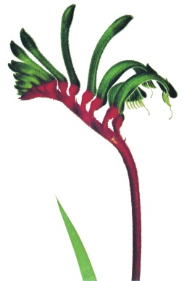](http://www.google.com.au/url?sa=i&source=images&cd=&cad=rja&docid=jDnlAamA--g6UM&tbnid=Ka29PqnSKeMVoM:&ved=0CAgQjRwwAA&url=http%3A%2F%2Fwww.dpc.wa.gov.au%2FGuidelinesAndPolicies%2FSymbolsOfWA%2FPages%2FFloralEmblemRedAndGreenKangarooPaw.aspx&ei=SwU0Ue-RCcXjmAWogIH4CQ&psig=AFQjCNEaEO-HErEGS5CypnXrSMcVUlRZUA&ust=1362450123252315)

Task 3

Use the information on Page 12 to identify the flowers that represent each Australian State.

Find pictures online of the flowers connected to each of the Australian States and create a Keynote Presentation.

Use Google Maps to research famous landmarks from each State.

Each slide needs a title (the state), map of the State, a picture of the flower and a picture of a local landmark. You may also include other interesting facts about the State.

MC900202616[1]

Task 4

Film Directors

Read pages 20-21- Underground Orchid. Imagine you are Mr Trott or a News reporter interviewing Mr Trott.

Task: Work in a small group to create a short iMovie of an interview between the reporter and Mr Jack Trott. You will need to write a short script for the interview including relevant questions from the text.



Task 5

MC900438193[1]Voice Recording

With a partner, use your Mac Books to record yourselves reading ‘The return of the Flowers’. You can choose to record in QuickTime, Keynote (with pictures), or with Garage Band.

[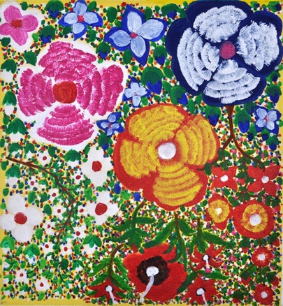](http://www.google.com.au/url?sa=i&rct=j&q=aboriginal+flowers&source=images&cd=&cad=rja&docid=IrgOhvIoRp2ZiM&tbnid=QTMTr2V085_FdM:&ved=0CAUQjRw&url=http%3A%2F%2Fwww.mukmuk.com%2Fgallery%2Fby-artist%2Fangelina-george%2Fbush-flowers-a3036%2F&ei=vAc0UcjeJYTqmAW2loHoAg&bvm=bv.43148975,d.dGY&psig=AFQjCNFxI08f-oo6Bi205YxOO5R3C3cdLA&ust=1362450727109550)