Task 1

How the Sun was Made.

1. When darkness covered the Earth, how was the only light made?
2. Why were the animals not happy?
3. What did the Brolga do when she got angry?
4. What did the yellow yolk spill on to?
5. The ground
6. The Emu’s head
7. The fire
8. On the Brolga’s head.
9. Choose a paragraph to illustrate. Re-write the paragraph underneath the picture.
10. What is a Goo-goor-gaga?

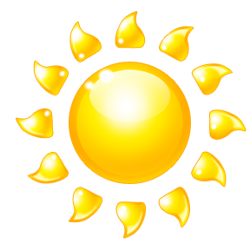

1. What is the Goo-goor-gaga’s job?

Task 2

Read the fact files on pages 10-13. Choose another animal that you’re interested in and create a fact file for that animal. You need to include the following information.

* Name
* Animal Type
* Aboriginal Name
* Food
* Size
* Habitat
* Range
* Trivia/ Interesting Facts

[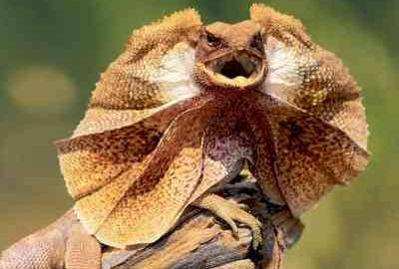](http://www.google.com.au/url?sa=i&rct=j&q=frilled+neck+lizard+pictures&source=images&cd=&cad=rja&docid=7cdglXUSezCCcM&tbnid=D5T-SqZtjrbYBM:&ved=0CAUQjRw&url=http%3A%2F%2Fgoaustralia.about.com%2Fod%2Fseethenativefauna%2Fss%2Ffrilled-neck-lizard.htm&ei=zfczUZ_0AoLOmgWY4ICYCg&bvm=bv.43148975,d.dGI&psig=AFQjCNF35SSQA-RC468DmVPoOlT9AicPgQ&ust=1362446666921278)

Task 3

Create a Keynote presentation using the information found on pages 14-23.

Your headings should include:

* Aboriginal People and the Stars
* The Morning Star
* The Sun
* The Life Cycle of the Sun
* The Southern Lights

You are not re-writing the book! Just use key points of information. Include interesting and relevant facts and pictures.

[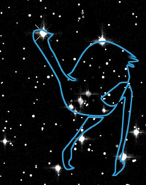](http://www.google.com.au/url?sa=i&source=images&cd=&cad=rja&docid=uHXq8jnoOKVSyM&tbnid=Ljd8lkXXsfSngM:&ved=0CAgQjRwwAA&url=http%3A%2F%2Fwww.abc.net.au%2Fscience%2Farticles%2F2005%2F08%2F16%2F1437646.htm&ei=9_gzUcDtL6qKmQX05IHgAg&psig=AFQjCNGgJNy7q3jYHsc07kTCuE6pSW0Isw&ust=1362446967814765)

MC900438193[1]Task 4:

Voice Recording

With a partner, use your Mac Books to record yourselves reading ‘How the sun was made’. You can choose to record in QuickTime, Keynote (with pictures), or with Garage Band.

MC900389354[1]