Task 1:

Story Board

Read the story. If you could only retell the story in 7 sentences, what would those sentences be?

Create a pages document listing your 7 sentences. Use those 7 sentences to create a storyboard retelling the main events from the narrative.

You will need 9 boxes. The 1st Box will be the Title Page and the Last box will have your name. You can choose to create the storyboard on paper or in comic life. You need to include illustrations

|  |  |  |
| --- | --- | --- |
| ___________________________  ___________________________ | ___________________________  ___________________________ | ___________________________  ___________________________ |
| ___________________________  ___________________________ | ___________________________  ___________________________ | ___________________________  ___________________________ |
| ___________________________  ___________________________  ___________________________ | ___________________________  ___________________________ | ___________________________  ___________________________ |

MC900383640[1]

**Task 2**

**Life Cycles**

Head to this website and answer the questions: <http://www.kidzone.ws/animals/lifecycle.htm>

A. What does the word ‘**metamorphosis**’ mean?

B. List 2 ways animals can be **born**

1.

2.

C. Some animals have **3 stages** in their life cycle. What are the **3 stages**? Draw the Diagram

1.

2.

3.

D. Some animals have **4 stages** in their life cycle. What are the **4 stages**? Draw the Diagram

1.

2.

3.

4.

Find 3 more interesting facts.

**Task 3**

**Research Report**

**Butterflies**

Choose a butterfly to research. Present your findings using a report, a poster or a Keynote Presentation. You need to include information on the name, type, aboriginal name, food, size, habitat and interesting facts.

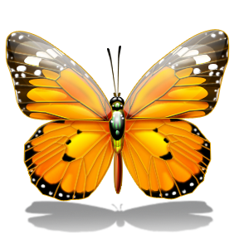

Additional information can be found at

<http://www.zoomdinosaurs.com/subjects/butterfly/>

Task 4

Read ‘The Cockatoo Fact File’ on page 18. Use the information on pages 20-23 to create a ‘Fact File’ for Wombats.

* Name
* Animal Type
* Aboriginal Name
* Food
* Size
* Habitat
* Range
* Trivia/ Interesting Facts

MC900186206[1]

MC900438193[1]Task 5:

Voice Recording

With a partner, use your Mac Books to record yourselves reading ‘How the Butterflies came to be’. You can choose to record in QuickTime, Keynote (with pictures), or with Garage Band.

[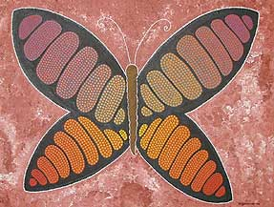](http://www.google.com.au/url?sa=i&rct=j&q=aboriginal+butterfly&source=images&cd=&cad=rja&docid=k0swaRNXWwHqdM&tbnid=ih9QVdsSoCigcM:&ved=0CAUQjRw&url=http%3A%2F%2Fwww.natsart.com.au%2Fgallery-03.htm&ei=CM8yUb2iD-HomAX8mIH4Dw&bvm=bv.43148975,d.dGY&psig=AFQjCNEPuAnuV5Zjq9GY1oz-eYsnjfH4zQ&ust=1362370675953713)