Task 1:

Story Board

Read the story. If you could only retell the story in 7 sentences, what would those sentences be?

Create a pages document listing your 7 sentences. Use those 7 sentences to create a storyboard retelling the main events from the narrative.

You will need 9 boxes. The 1st Box will be the Title Page and the Last box will have your name. You can choose to create the storyboard on paper or in comic life. You need to include illustrations

|  |  |  |
| --- | --- | --- |
| ___________________________  ___________________________ | ___________________________  ___________________________ | ___________________________  ___________________________ |
| ___________________________  ___________________________ | ___________________________  ___________________________ | ___________________________  ___________________________ |
| ___________________________  ___________________________  ___________________________ | ___________________________  ___________________________ | ___________________________  ___________________________ |

MC900383640[1]

Task 2

Read ‘The Sandpiper Fact File’ on page 8. Use the information on pages 12-17 to create a ‘Fact File’ for Whales.

* Name
* Animal Type
* Aboriginal Name
* Food
* Size
* Habitat
* Range
* Trivia/ Interesting Facts

MC900332336[1]

Task 3

Read the news article on page18. Use the information to identify Who, What Where, Why and How.

MC900434313[1]

Task 4

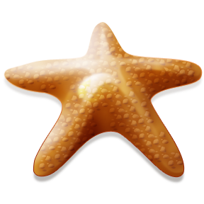Read pages 22 and 23. Create a brochure or poster that gives people information about First Aid for Starfish stings

MC900438193[1]Task 5:

Voice Recording

With a partner, use your Mac Books to record yourselves reading ‘How the Animals Came to Australia’. You can choose to record in QuickTime, Keynote (with pictures), or with Garage Band.

MC900356113[1]