Name: _________________________
Directions: 1. Write the rhyme scheme by writing the appropriate letter next to each line. Approximate rhymes are allowed. 2. Write the number of syllables for each line next to the line. 3. Answer the questions on the back.
"Sarah Cynthia Sylvia Stout Would Not Take the Garbage Out"
Shel Silverstein

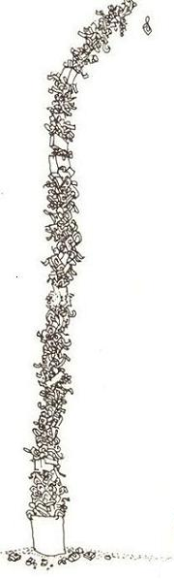
15
10
5

Sarah Cynthia Sylvia Stout
Would not take the garbage out!
She'd scour the pots and scrape the pans,
Candy the yams and spice the hams,
And though her daddy would scream and shout,
She simply would not take the garbage out.
And so it piled up to the ceilings:
Coffee grounds, potato peelings,
Brown bananas, rotten peas,
Chunks of sour cottage cheese.
It filled the can, it covered the floor,
It cracked the window and blocked the door
With bacon rinds and chicken bones,
Drippy ends of ice cream cones,
Prune pits, peach pits, orange peel,
Gloppy glumps of cold oatmeal,
Pizza crusts and withered greens,
Soggy beans and tangerines,
Crusts of black burned buttered toast,
Gristly bits of beefy roasts...
20
The garbage rolled on down the hall,
It raised the roof, it broke the wall...
Greasy napkins, cookie crumbs,
Globs of gooey bubble gum,
25
Cellophane from green baloney,
Rubbery blubbery macaroni,
Peanut butter, caked and dry,
Curdled milk and crusts of pie,
Moldy melons, dried-up mustard,
30
Eggshells mixed with lemon custard,
Cold french fries and rancid meat,
Yellow lumps of Cream of Wheat.
At last the garbage reached so high
That finally it touched the sky.
35
And all the neighbors moved away,
And none of her friends would come to play.
And finally Sarah Cynthia Stout said,
"OK, I'll take the garbage out!"
But then, of course, it was too late...
40
The garbage reached across the state,
From New York to the Golden Gate.
And there, in the garbage she did hate,
Poor Sarah met an awful fate,
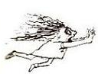
That I cannot right now relate
45
Because the hour is much too late.
But children, remember Sarah Stout
And always take the garbage out!
1. Find six examples of alliteration:
_______________________________________
_______________________________________
_______________________________________
_______________________________________
_______________________________________
_______________________________________

2. Find two examples of repetition:
_______________________________________
_______________________________________

3. Find eight adjectives that describe the mess:
________________ _______________
________________ _______________
________________ _______________
________________ _______________

4. Find a hyperbole:
_______________________________________

5. Write two lines that have end rhyme:
_______________________________________
_______________________________________

